# Types of Opportunity

## Opportunity Pull

Opportunity Pull occurs when the potential size and attractiveness of an opportunity draw in entrepreneurs and businesses aiming to exploit it. This type of opportunity arises from a clear demand or need in the market, which motivates innovators to develop solutions that meet this demand.

**Example:**

A drug to mitigate the effects of Alzheimer’s disease represents an opportunity pull. The substantial need for effective treatments for Alzheimer’s, a widespread and impactful condition, attracts researchers and pharmaceutical companies to develop drugs that can address this critical medical need.

## Capability Push

Capability Push, on the other hand, is driven by the emergence of a new technology or capability, prompting a search for potential applications. This type of opportunity stems from technological advancements or innovations that inspire entrepreneurs to explore new uses for these capabilities, often leading to the creation of entirely new markets or industries.

**Example**:

Digital Television illustrates capability push. The development of digital broadcasting technology prompted companies to seek new applications for this technology, leading to innovations in broadcasting, content delivery, and viewing experiences.

# Nine Categories of Opportunity

These categories represent different ways in which businesses can identify and exploit opportunities to create value, innovate, and grow.

1. **Increasing the value of a product or a service**: Enhancing existing products or services to offer greater benefits to customers.
2. **New applications of existing means or technologies**: Finding innovative uses for current technologies or resources in different contexts.
3. **Customization for individuals:** Tailoring products or services to meet the specific needs and preferences of individual customers.
4. **Convergence of industries:** Combining elements from different industries to create new products, services, or business models.
5. **Process innovation:** Developing new or improved processes that increase efficiency, quality, or performance.
6. **Increasing the scale of the firm**: Growing the size and capacity of the business to take advantage of economies of scale and market opportunities.

# Evaluating an Opportunity: Sources of Discontinuities

Discontinuities are significant changes or disruptions that can create new opportunities or challenges for businesses. These sources of discontinuities can come from societal shifts, technological advancements, or market changes.

## **I. Society**

1. **Aging society**: The increasing proportion of elderly individuals in the population can drive demand for products and services tailored to their needs, such as healthcare, assisted living, and recreational activities.
2. **Lifelong education:** The growing emphasis on continuous learning and skill development throughout one's life can create opportunities in educational services, training programs, and online learning platforms.
3. **Food and population**: Changes in population dynamics and food consumption patterns can affect agricultural practices, food production, and distribution systems.
4. **Regulation**: New laws and regulations can create opportunities by opening up markets or necessitating compliance-related products and services.

## **II. Technology**

1. **Innovation**: Breakthroughs in technology can spawn new products, services, and industries.
2. **Disruptive technologies**: Innovations that fundamentally change existing markets or create new ones by displacing established technologies.
3. **New knowledge:** Advancements in scientific and technical knowledge can lead to the development of novel applications and solutions.

## **III. Markets**

1. **Deregulation**: The removal of regulatory restrictions can open up new markets and increase competition.
2. **Supply chain disruption**: Events that disrupt the normal flow of goods and materials can create opportunities for businesses that can adapt quickly or offer alternative solutions.

# **Concept statement:**

A concept statement is a one-page description of a product idea that is distributed to people who are asked to provide feedback on the potential of the idea.

▪ A description of the product

▪ The intended target market

▪ The benefits provided by the product

▪ The point of differentiation relative to existing solutions

▪ A short description of the team

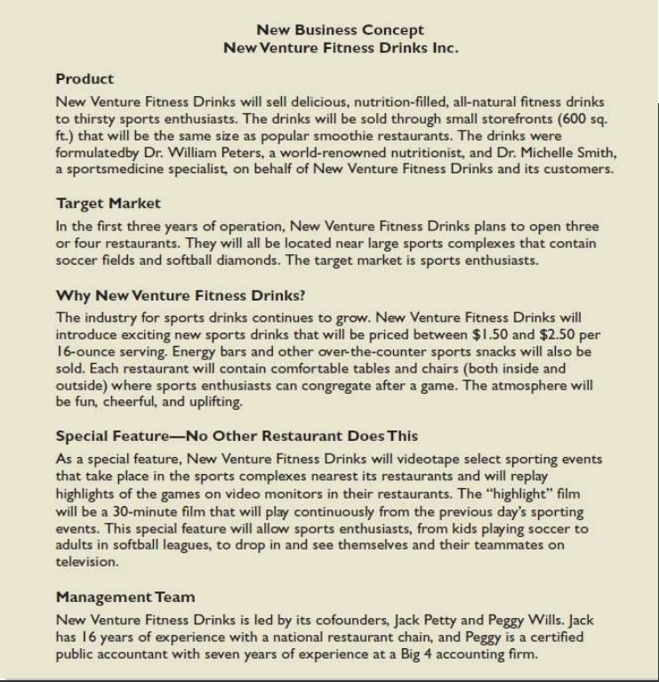

# **Core Competency:**

A core competency is a unique capability or advantage that a company possesses, which is central to its ability to compete in the marketplace. Core competencies are fundamental strengths that are difficult for competitors to replicate and provide the foundation for a company's long-term success.

# **First Movers Versus Followers**

**First-Mover Advantage:**

The "first-mover advantage" refers to the benefits a company gets by being the first to introduce a new product, service, or technology to the market. These benefits can include:

**Brand Recognition:** Being first helps a company build a strong brand name and recognition.

**Customer Loyalty:** Early entrants can develop loyal customers before competitors arrive.

**Market Share:** The company can capture a large portion of the market early on.

**Setting Standards:** The first mover can set industry standards and expectations.

Example: **Google** was not the first search engine but was the first to effectively rank web pages based on relevance and popularity, which revolutionized online search. This innovation allowed Google to dominate the market and become synonymous with online search.

**First Movers vs. Followers**

**First Movers:** These are the companies that introduce new products or services to the market first.

**Fast Followers**: These companies wait for the first movers to enter the market and then quickly follow with their own versions, often improving on the first mover's offerings.

**Advantages of First Movers:**

**Establish Strong Brand Recognition:** Being first helps in creating a strong brand identity.

**Build Customer Loyalty:** They can secure loyal customers early.

**Gain Significant Market Share:** Capturing a large portion of the market before competitors enter.

**Set Industry Standards:** First movers can influence industry norms and expectations.

**Example:**

**Amazon**: Originally started as the first major online bookstore. Their early success in selling books online allowed them to establish significant brand recognition and later expand into selling a wide range of products.

**Apple**: Launched the first iPhone in 2007, revolutionizing the mobile phone industry. This first move changed the market and set new standards for smartphones.

**Disadvantages and Risks:**

**High Risk:** There is a risk that customers may not accept the new product or service.

**Need for Continuous Innovation:** The first mover must keep innovating and adapting to maintain their lead.

**Market Changes:** If the market conditions change, the first mover needs to quickly adapt to sustain their advantage.

**Example:**

**Uber**: As the first major ride-sharing service, Uber established a new market. However, they continually need to innovate and adapt to changing regulations and competition to maintain their position.

# **Industry Life Cycle Stages**

1. **Emergent Industries**

**Definition**: These are newly created or recently recreated industries, often emerging due to new products, new customer needs, or changes in the business environment.

**Characteristics**:

* 1. **Limited Information:** There is often a lack of detailed information about products and competitors.
  2. **Unclear Demand:** Consumer demand is uncertain and hard to predict.
  3. **Innovation**: High level of innovation and experimentation as companies try to establish themselves.
  4. **High Risk:** The uncertainty makes these industries risky but also potentially very rewarding for early entrants.

**Example**: The early days of the virtual reality (VR) industry, where new products and applications were being developed with unclear demand patterns.

1. **Growing Industries:**

**Definition**: Industries that are experiencing moderate revenue growth with increasing consumer acceptance and moderate levels of stability and uncertainty.

**Characteristics:**

* 1. **Rapid Demand Growth**: Consumers begin to understand and value the new offerings, leading to rapid growth in demand.
  2. **Increased Competition:** More companies enter the market as the potential for profit becomes clear.
  3. **Investment**: Significant investment in marketing, infrastructure, and scaling operations.
  4. **Moderate Stability:** The industry starts to stabilize as the market becomes more defined.

**Example**: The electric vehicle (EV) industry, which is seeing rapid growth as consumers increasingly accept EVs as viable alternatives to traditional cars.

1. **Mature Industries**

**Definition**: Industries that have reached a stage where growth slows significantly, and companies focus on efficiency and competition intensifies.

**Characteristics:**

* 1. **Slow Revenue Growth:** Revenue growth is slow, indicating a saturated market.
  2. **High Stability:** The industry is stable, with established leaders and clear market segments.
  3. **Intense Competition:** Competition becomes fierce as companies fight for market share in a stagnant or slowly growing market.
  4. **Shakeout Period**: Early in the maturity phase, weaker competitors are often forced out or consolidated into stronger companies.
  5. **Efficiency Focus**: Companies focus on reducing costs and improving efficiencies to maintain profitability.

**Example**: The personal computer industry, where growth has slowed, and companies compete heavily on price, features, and brand loyalty.

# Common Vision Statements for Different Industries

**1. Social Media Platform**

**Vision**: "To connect people around the world and foster meaningful interactions that inspire and **empower** communities."

**Mission**: "To create a safe, inclusive, and engaging platform where users can share their stories, connect with others, and discover new perspectives."

**2. Service for the Betterment of People (e.g., Online Food Delivery)**

**Vision**: "To make healthy and delicious food accessible to everyone, anytime and anywhere, while **supporting** local farmers and **reducing** food waste."

**3. Service for the Betterment of People (e.g., Online Ride Booking)**

**Vision**: "To **revolutionize** urban mobility by providing safe, affordable, and eco-friendly transportation options that **enhance** the quality of life for everyone."

**Mission**: "To provide **reliable** and **affordable** rides through a user-friendly app, **ensuring safety** and convenience while **reducing** our carbon footprint with sustainable transportation solutions."

**4. Educational Purpose**

Vision: "To **democratize** education by providing high-quality, accessible learning opportunities for all, **empowering** individuals to achieve their full potential."

**5. Healthcare Services**

Vision: "To improve global health by providing **innovative** and **compassionate** care that is accessible to all, enhancing the quality of life and **promoting well-being**."

**6. E-commerce Platform**

Vision: "To create a **seamless** and **enjoyable** online shopping experience that offers a **diverse range** of products and **supports** small businesses worldwide."

**7. Environmental Conservation**

Vision: "To **protect** and **restore** the natural world by leading global efforts in conservation, sustainability, and environmental education."

**8. Financial Services (e.g., Fintech)**

**Vision**: "To **empower** individuals and businesses through innovative financial solutions that **promote** financial literacy, inclusion, and economic growth."

**Mission**: "To provide accessible and user-friendly financial services and tools that help people manage their finances better, achieve their economic goals, and foster financial independence and security."

**9. Entertainment (e.g., Streaming Services)**

Vision: "To bring joy and inspiration to people's lives by offering diverse and engaging entertainment experiences, accessible anytime, anywhere."

**10. Technology and Innovation**

Vision: "To drive technological advancement and innovation that **transforms** industries, **improves** lives, and **creates** a smarter, more connected world."

# **Decision Making**:

Decision making is the process of making choices by identifying a decision, gathering information, and assessing alternative resolutions.

Following are steps of decision making:

**Step#1** Identify the Problem.

**Step#2** Establish Decision Criteria.

**Step#3** Weigh Decision Criteria.

**Step#4** Generate Alternatives.

**Step#5** Evaluate Alternatives.

**Step#6** Select the Best Alternative

## **Example 1**:

Maham is the CEO of the company who observes that machinery productivity has gone downwards because of the uncertain death of their technically skilled employee who was serving for that designation. To overcome this problem she has to go through the decision making process, which has the following six steps:

**Step#1 Identify the Problem**

The problem is that we have a position that needs to be filled within our company. We need to find a qualified candidate who can perform the technical job duties effectively.

**Step#2 Establish Decision Criteria**

To make this decision, we need to establish some criteria that the new employee must meet. These criteria might include things like relevant work experience, education, skills, language known, certification, technical knowledge.

**Step#3 Weigh Decision Criteria**

Once we have established our decision criteria, we need to weigh them in order of importance. For example, technical skill and work experience might be more important than any other requirement as these are essential for running the machineries efficiently.

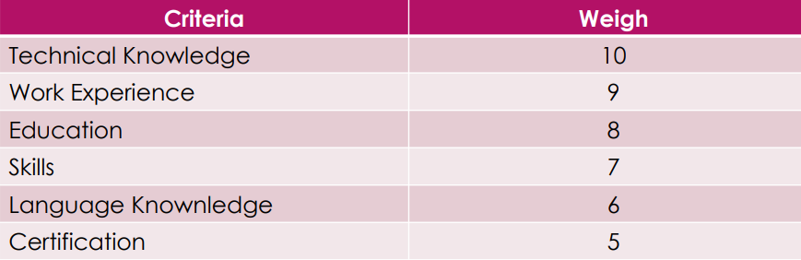

**Step#4 Generate Alternatives**

Next, we need to generate alternatives for potential candidates who meet our decision criteria. This might involve posting job listings on various platforms, reaching out to recruitment agencies or headhunters, and asking for referrals from current employees.

**Step#5 Evaluate Alternatives**

Once we have received applications and resumes from potential candidates, we need to evaluate each one against our decision criteria. This might involve conducting interviews with each candidate, checking references and work history, and analyzing how well each candidate meets our specific needs. So we get:

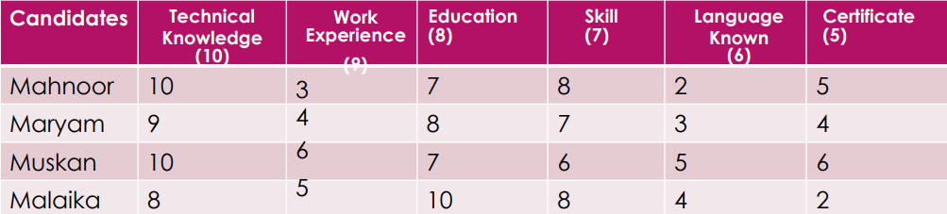

**Step#6 Select the Best Alternative.**

Finally, we need to select the best alternative based on our evaluation of each candidate. This might involve weighing the pros and cons of each candidate and making a final decision based on which candidate best meets our needs. The candidate having the highest weighting will be selected .

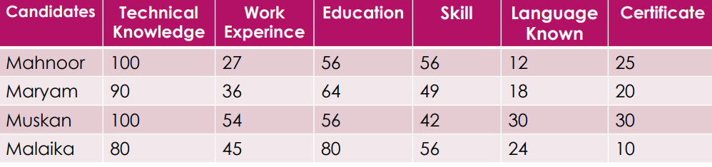

In the end, we would select the candidate who best meet our needs. Like here Muskan has the highest weighting showing that she is the best match for the desired designation.

## **Example 2:**

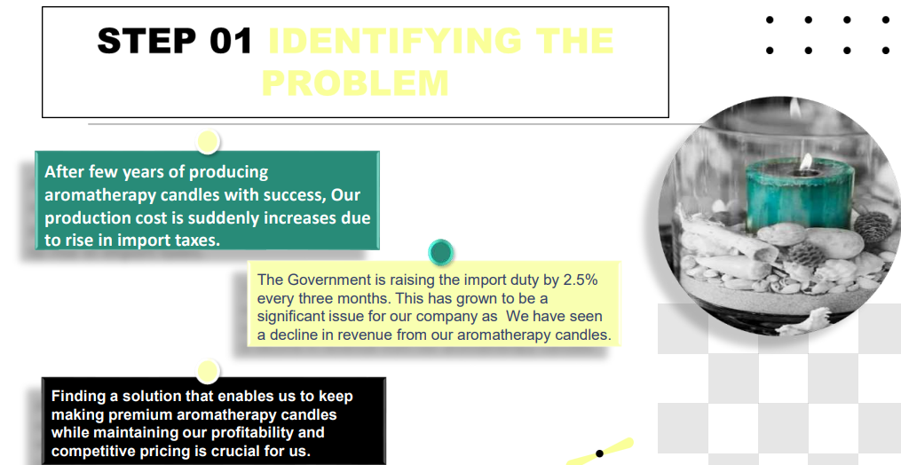

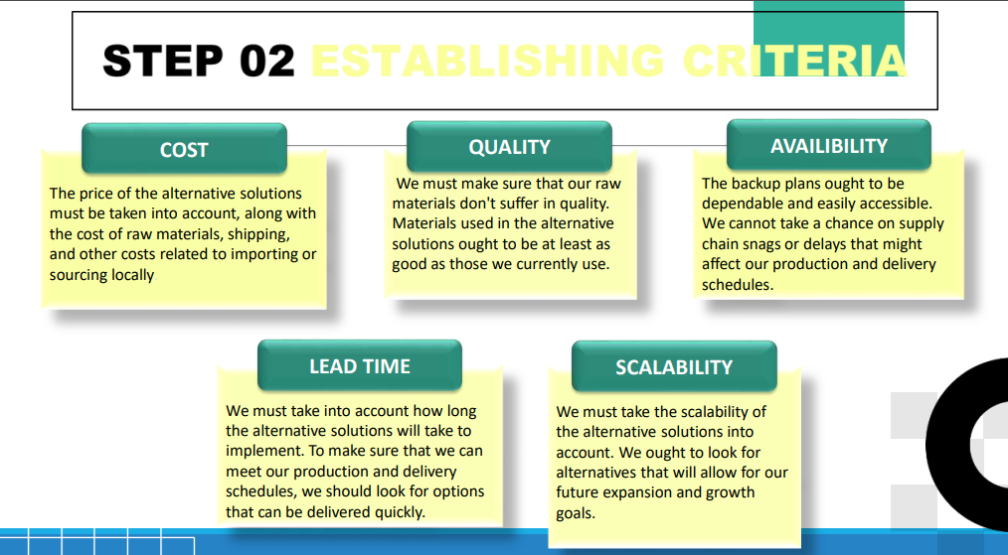

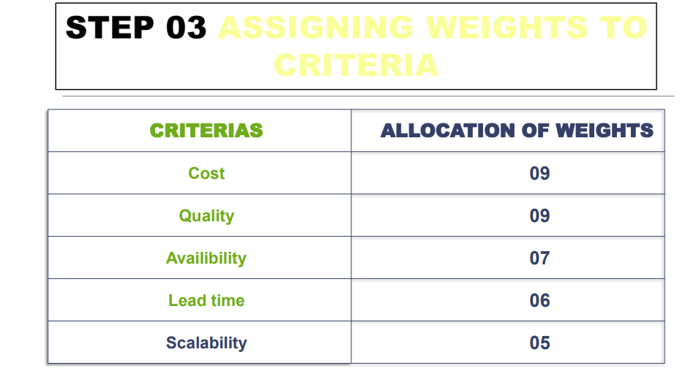

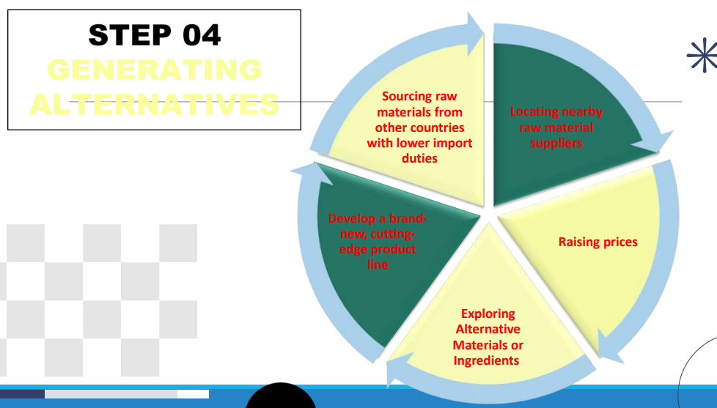

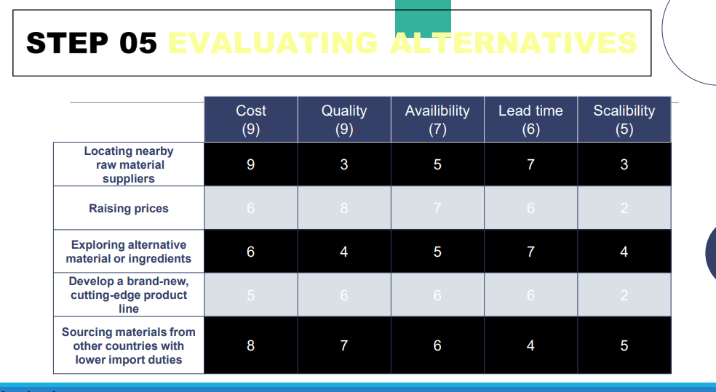

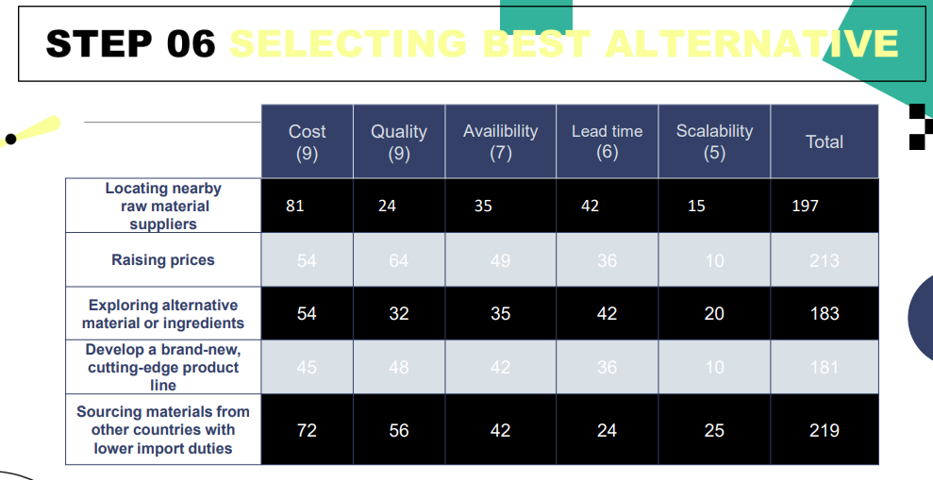

## **Decision-Making Styles**

1. **Reflexive Style**

Makes quick decisions without taking the time to get all the information that may be needed and without considering all the alternatives.

1. **Reflective Style**

Takes plenty of time to make decisions, gathering considerable information and analyzing several alternatives.

1. **Consistent Style**

Tends to make decisions without either rushing or wasting time.

## **Decision-Making Conditions :**

1. **Certainty** ◦ Each alternative’s outcome is known in advance.
2. **Risk** ◦ Probabilities can be assigned to each outcome.
3. **Uncertainty** ◦ Lack of information or knowledge makes the outcome of each alternative unpredictable such that no probabilities can be determined.

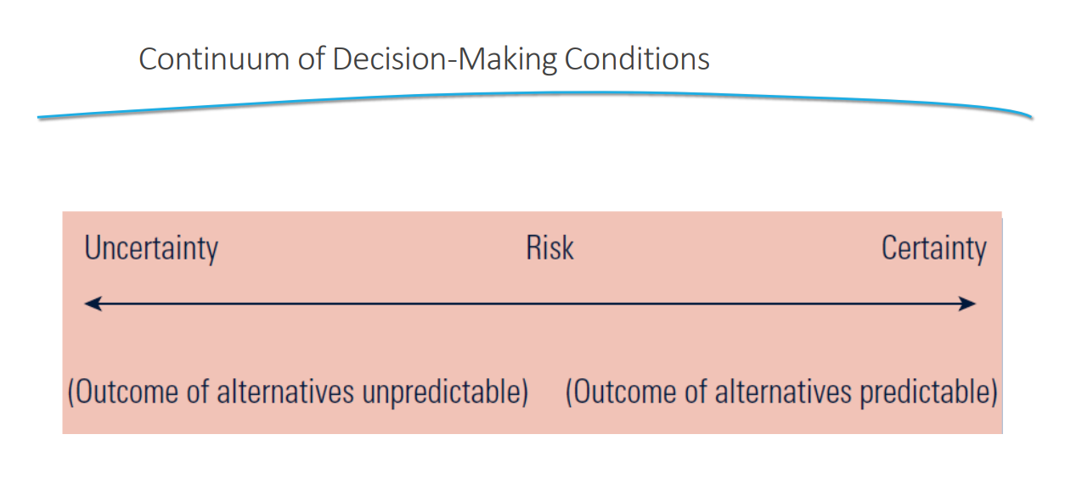

# **Types of risks** :

### **1. Strategic Risk**

Strategic risks come from making big decisions about your business's direction. These risks can affect your long-term success.

**Examples:**

* **Competitor entry**: If a new business starts selling a similar product at a lower price, it can hurt your sales.
* **Technological changes**: If you run a video rental store and people start streaming movies online, your business could suffer.
* **Shifts in customer demand**: If you sell DVD players and everyone switches to streaming services, your sales will drop.

### **2. Compliance and Regulatory Risk**

Compliance risks are about following laws and regulations. If you don’t follow these rules, you could face fines or other penalties.

**Examples:**

* **Corruption**: Paying bribes to win contracts is illegal and can lead to severe penalties.
* **Discrimination or harassment**: If your employees face harassment and you don’t address it, your business could face lawsuits.
* **Workplace health and safety violations**: If you don’t provide a safe work environment, accidents can happen, leading to fines and lawsuits.
* **Environmental regulations**: Dumping waste improperly can result in hefty fines and damage your reputation.
* **Data storage issues**: Mishandling customer data can lead to breaches, resulting in penalties and loss of trust.

### **3. Financial Risk**

Financial risks involve the management of money and can impact your business’s financial health.

**Examples:**

* **Interest rate rises**: If the interest rate on your business loan goes up, you’ll have to pay more each month, which can affect your profits.
* **Non-paying customers**: If customers don’t pay their bills on time, your cash flow can suffer, making it hard to pay your own bills.

### **4. Operational Risk**

Operational risks are related to your daily business operations and can cause disruptions.

**Examples:**

* **Breakdown of key equipment**: If a critical machine in your factory breaks down, production can stop until it’s fixed.
* **Theft of key equipment**: If essential equipment is stolen, you might not be able to operate until it’s replaced.
* **Supply chain disruptions**: If your supplier fails to deliver materials on time, your production can be delayed.
* **Human error**: Mistakes made by employees, like sending the wrong order to a customer, can cause problems and cost money to fix.

### **Managing and Treating Risks**

Here’s how you can handle these risks:

* **Avoidance**: Stop doing activities that create high risk. For example, stop selling a product that has safety issues.
* **Mitigation**: Take steps to reduce the risk. For example, install security cameras to prevent theft.
* **Transfer**: Move the risk to someone else. For example, buy insurance to cover potential losses.
* **Acceptance**: Accept the risk and plan how to deal with it. For example, set aside money to cover potential bad debts from non-paying customers.

## **Risk management**

Risk management in entrepreneurship involves identifying, assessing, and prioritizing risks to minimize their impact on the business. Entrepreneurs face numerous uncertainties, and effective risk management helps navigate these uncertainties to ensure business success. Here's a breakdown of risk management in entrepreneurship:

### **1. Identify Risks**

The first step is to identify potential risks that could affect the business. These risks can be internal (within the company) or external (outside the company).

**Examples:**

* **Market risks**: Changes in customer preferences or new competitors.
* **Operational risks**: Equipment failures or supply chain issues.
* **Financial risks**: Cash flow problems or rising interest rates.
* **Compliance risks**: Changes in laws or regulations.

### **2. Assess Risks**

Once risks are identified, the next step is to assess their likelihood and potential impact on the business.

**Questions to ask:**

* How likely is this risk to occur?
* What would be the consequences if it did occur?
* How severe would the impact be on the business?

### **3. Prioritize Risks**

Not all risks are equal. Entrepreneurs need to prioritize risks based on their potential impact and likelihood of occurring.

**Prioritization criteria:**

* High-impact, high-likelihood risks should be addressed first.
* Low-impact, low-likelihood risks can be monitored and managed as needed.

### **4. Develop Risk Management Strategies**

Entrepreneurs should create strategies to manage the prioritized risks. These strategies can include:

* **Avoidance**: Eliminating activities that expose the business to high risks.
  + Example: If a new product has high safety risks, decide not to launch it.
* **Mitigation**: Taking steps to reduce the likelihood or impact of risks.
  + Example: Implementing quality control processes to reduce product defects.
* **Transfer**: Shifting the risk to another party, such as through insurance or outsourcing.
  + Example: Purchasing insurance to cover potential damages from natural disasters.
* **Acceptance**: Acknowledging the risk and preparing to deal with its consequences.
  + Example: Setting aside a contingency fund to cover unexpected expenses.

### **5. Implement Risk Management Plans**

Put the developed strategies into action. This might involve changing business processes, training employees, or purchasing insurance.

**Implementation steps:**

* Communicate the plan to all relevant stakeholders.
* Assign responsibilities for managing specific risks.
* Ensure resources are available to support risk management efforts.

### **6. Monitor and Review**

Regularly monitor risks and the effectiveness of your risk management strategies. This helps ensure that new risks are identified and managed promptly.

**Monitoring activities:**

* Regular risk assessments and audits.
* Keeping up with industry trends and changes.
* Gathering feedback from employees and customers.

# **Break even**

# 

You need to decide whether to make or buy 15,000 units of a part each year.

**Costs to Make the Part:**

* Fixed cost: $25,000 for equipment.
* Variable cost: $5 per unit.

**Costs to Buy the Part:**

* Fixed cost: $500 for preparing the contract.
* Variable cost: $7 per unit.

### **Finding the Break-even Point**

1. **Calculate Total Costs for Each Option:**
   * **To Make:**
     + Total Cost to Make = Fixed Cost + (Variable Cost per Unit × Number of Units)
     + Total Cost to Make = $25,000 + $5 × Q
   * **To Buy:**
     + Total Cost to Buy = Fixed Cost + (Variable Cost per Unit × Number of Units)
     + Total Cost to Buy = $500 + $7 × Q
2. **Set the Two Equations Equal to Find the Break-even Point:**
   * $25,000 + $5Q = $500 + $7Q
   * Subtract $500 from both sides: $24,500 + $5Q = $7Q
   * Subtract $5Q from both sides: $24,500 = $2Q
   * Divide both sides by 2: $24,500 ÷ 2 = Q
   * Q = 12,250 units

### **Break-even Point**

At 12,250 units, the total cost to make the part is equal to the total cost to buy the part.

### **What Does This Mean?**

* If you need exactly 12,250 units, it costs the same whether you make or buy.
* If you need more than 12,250 units, making the part is cheaper.
* If you need fewer than 12,250 units, buying the part is cheaper.

### **For 15,000 Units**

Since you need 15,000 units (which is more than the break-even point of 12,250 units):

* **To Make:**
  + Total Cost to Make = $25,000 + ($5 × 15,000) = $25,000 + $75,000 = $100,000
* **To Buy:**
  + Total Cost to Buy = $500 + ($7 × 15,000) = $500 + $105,000 = $105,500

### **Conclusion**

* **Cost to Make 15,000 units:** $100,000
* **Cost to Buy 15,000 units:** $105,500

**Cheaper Option: Make the part yourself** because it costs $100,000 compared to $105,500 for buying.

# **Intellectual Property (IP)**

“Intellectual property (IP) refers to creations of the mind: inventions, literary and artistic works, symbols, names, images and designs used in commerce.”

**IP comes in several forms:**

▪ Patents – technical features of innovations

▪ Trade Marks – brand names and logos

▪ Registered Designs – appearance

▪ Copyright – graphical and literary material

**Why Protect An Idea?**

Legal protection of your new idea or invention ensures the future position of your company/brand and enables you to make money in a highly competitive market place

It stops others from copying your idea allowing you to maximise the return you deserve for investing you time, capital and resources in the invention of the idea.

**Types of Intellectual Property**

• Copyrights

• Trademarks & Service marks

• Patents

**1. TRADEMARK**

A trademark is a word, phrase, symbol, and/or design that identifies and distinguishes the source of the goods of one party from those of others. A service mark is a word, phrase, symbol, and/or design that identifies and distinguishes the source of a service rather than goods. Examples include brand names, slogans, and logos. (The term “trademark” is often used in a general sense to refer to both trademarks and service marks.) Trademark can be registered, and then use ™ ®. The registration validity is for 7 years and renewable after expiry.

**Trademarks**

• VERY important IP right

• Brand identity – market niche protection

• Reduce clutter. Prevent confusion. Distinguish.

• Relatively inexpensive to protect (compared to patent

protection)

• Work well across borders, cultures, and languages

• Long-term protection while in use (QUAKER – 1895)

• Provide value for expansion beyond core business

• Assigned, pledged, licensed

• Registration is importa

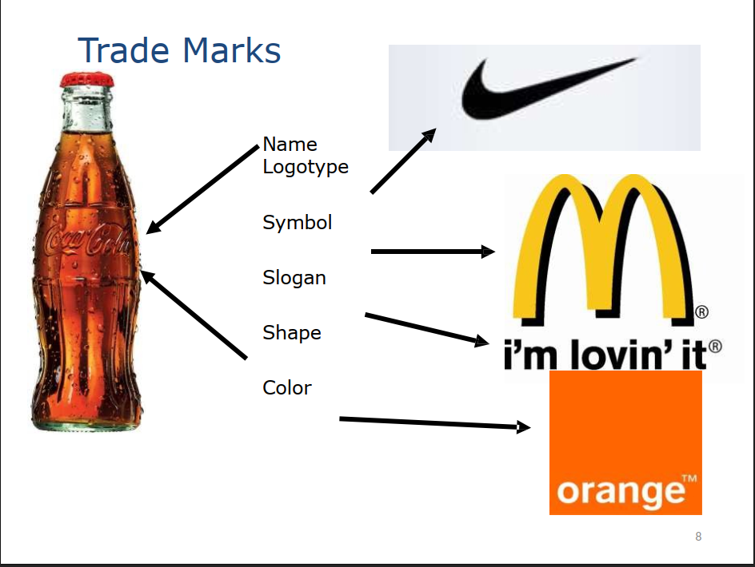

**Trademarks & Service marks**

• Indicates source of goods and services

• Word, name, symbol, device, sound, color

• Used to distinguish your goods and services

from those sold by others

• Brand identity

**2. Patents**

Patents are the only mechanism for protecting technical ideas

A patent protects inventions. These inventions can include new

and useful processes, machines, manufactures,

compositions of matter as well as improvements to them.

The primary goal of the patent law is to encourage

innovation and commercialization of technological advances.

The Telephone: Patented by Alexander Graham Bell in 1876

**3. Registered Designs**

Design deals with features, shapes, patterns, etc., applied to an article by an industrial process, manual or mechanical. Eg., chair is a utility item. However, chair itself does not qualify for IPR, but its special carvings, embossing etc., is done which increases the value of chair though it’s utility remains same, it becomes eligible for IPR under Designs Act. Designs can be registered based on its originality, henceforth they can use ® or

registered, with registration number.

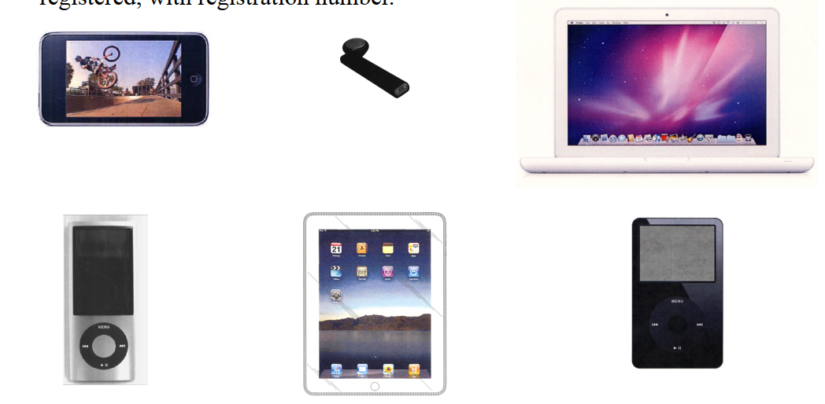

**4. Copyrights**

• Copyrights are legal protections on creative works of the mind, "original works of authorship."

• They include visual art, literary works, other writings, choreography, and software.

Copyrights prevent others from reproducing the work without the expressed permission of

the copyright owner.

**Examples**

▪ Books

▪ Sheet music, Recordin

▪ Photographs

▪ Paintings

▪ Software

▪ Company brochures

▪ Website content

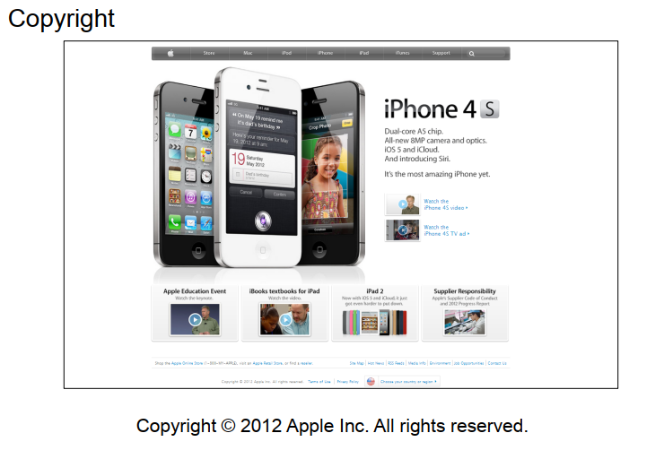

**Software Product Example**

• Copyright

– The code itself

– Structure, sequence, organization

• Trademark – the name

• Patent – the process

• Trade Secret – keep the source code secret

**Restaurant Example**

• Patent – recipes, Secret ingredients, etc.

• Trademarks – name, name of dish

• Copyright – web site, artwork

#### **Trademark**

* **Definition:** A trademark is a sign, design, or expression that identifies products or services of a particular source from those of others.
* Trademark can be registered, and then use ™ ®. The registration validity is for 7 years and renewable after expiry.
* **Example:** The Nike "swoosh" logo. When you see it, you know it's a Nike product.

#### **Registered Design**

* **Definition:** A registered design protects the visual design of objects that are not purely utilitarian. It covers the shape, configuration, pattern, or ornamentation of a product.
* **Example:** The unique shape of a Coca-Cola bottle. The bottle’s distinctive design is protected, making it instantly recognizable.

#### **Copyright**

* **Definition:** Copyright protects original works of authorship, such as books, music, and art. It prevents others from copying or using the work without permission.
* **Example:** The "Harry Potter" books by J.K. Rowling. Only Rowling (or those she gives permission to) can legally reproduce or sell her stories.

#### **Patent**

* **Definition:** A patent is a form of protection that gives an inventor exclusive rights to make, use, or sell an invention for a certain period of time. It protects new and useful processes, machines, or compositions of matter.
* **Example:** The technology behind the iPhone. Apple has patents that protect the innovative features and functions of its iPhone models.

### **Summary**

* **Trademark:** Identifies and distinguishes brand identity.
  + *Example:* Nike "swoosh" logo.
* **Registered Design:** Protects the appearance of a product.
  + *Example:* Coca-Cola bottle shape.
* **Copyright:** Protects original creative works.
  + *Example:* "Harry Potter" books.
* **Patent:** Protects new inventions and processes.
  + *Example:* iPhone technology.

# **Feasibility Analysis:**

1. **Product/Service FA**
   1. Product Demand
      1. Talk to experts
      2. Concept statement / feedbacks
   2. Product Desirability
      1. Talking Face-to-Face with Potential Customers
      2. Using online tools
      3. Library, internet and Gumshoe research
2. **Target Market / Industry**
   1. Industry Attractiveness
      1. 5 forces
      2. Early, fragmented, must have, growing
   2. Target Market Attractiveness
3. **Orgranizational**
   1. Management Prowess
      1. Passion
      2. Understand the market
   2. Resource Sufficiency
      1. 12 list of non financial resources (time, internet, space, mang emp, obtain IP protections etc
4. **Financial**
   1. Total Start-up cash needed
      1. Budget preparation that lists operating expenses and capital purchases
   2. Financial Performance of Similar Businesses
      1. Buy and read reports of other companies
      2. Find case studies, thesis, research ppr,